Truck Platooning System

Namık Mert Tunçbilek  
Matric No : 7213712 *Embedded Systems Engineering*  
*Fachhochschule Dortmund*  
Dortmund, Germany  
namk.tuncbilek001@stud.fh-dortmund.de

Veli Ateş  
Matric No : *Embedded Systems Engineering  
Fachhochschule Dortmund*Dortmund, Germany  
line 5: email address or ORCID Nijat Dashdamirov  
Matric No : 7213892 *Embedded Systems Engineering  
Fachhochschule Dortmund*Dortmund, Germany  
[nijat.dashdamirov002@stud.fh-dortmund.de](mailto:nijat.dashdamirov002@stud.fh-dortmund.de)

Vignesh Arumugam  
Matric No : 7213710 *Embedded Systems Engineering  
Fachhochschule Dortmund*Dortmund, Germany  
vignesh.arumugam002@stud.fh-dortmund.deMirudhubashini Ramasamy Sridharan  
Matric No : *Embedded Systems Engineering  
Fachhochschule Dortmund*Dortmund, Germany  
mirudhubashini.ramasamysridharan002@stud.fh-dortmund.de

*Abstract*—Truck Platooning is the future of transportation in which trucks drive agreeably at less than 1 moment separated made possible by automated driving innovation. Transportation companies’ advantage from lower fuel utilization and enhancements in (driver) efficiency, whereas society benefits from less mishaps, more secure activity and less congested streets, and lower carbon outflows.

Keywords—Platooning, mechanized driving, lower carbon

# Introduction

Transportation is vital to society and economy, and street cargo transportation accounts for about 60% of all surface cargo transportation. The request for street cargo transport is anticipated to extend within the coming a long time. As appeared within the American Trucking Association’s 2015 report, the trucking industry comprises about 80% of a 1.33 trillion-dollar shipping and coordination’s industry within the US. In any case, bounty of fuel utilization and nursery gas outflow have been created. For case, street transport speaks to around 27% of the vitality utilization of the European Union. Furthermore, indicated that vehicles account for 20% of the entire carbon emanation of which a quarter comes from overwhelming obligation vehicles (HDVs). Subsequently, the natural impacts amid the method of transport got to be diminished direly. In expansion, the fetched of fuel has an expansive share of add up to transportation costs. Fuel fetched spoken to about 30% of the life cycle taken a toll of owning and working a truck. Additionally, agreeing to the American Transportation Investigate Institute’s (ATRI) later report, fuel is respected as the moment biggest taken a toll, where the most elevated is faculty cost. With a huge sum of HDVs and the expanding request for street cargo, it can be anticipated that indeed small advances in fuel efficiency can decipher into significant taken a toll diminishment [1]. And it is additionally advantageous to realize the objective of natural assurance due to less deplete gas. As a result, it is of awesome advantage to move forward fuel economy, and how to decrease fuel utilization amid traveling has turned into a prevalent theme in later a long time. Luckily, the improvements of shrewdly transportation frameworks (ITSs) have empowered strategies to improve the vitality productivity of transportation systems. A promising approach to managing with that issue is to decrease the crevice between vehicles on the street, which is ordinarily called truck companies. Truck companies, moreover known as caravans, are a set of vehicles shaping a street prepare by traveling closely in single record to encounter diminished discuss drag. This may altogether diminish fuel utilization since around one-fourth of the fuel utilization is important to streamlined drag. As a result, fuel economy can be progressed and natural invitingness can be accomplished due to less nursery gas emanation in a unit. Separated from fuel reserve funds, truck units can to contribute to an increment of street capacity and can ease activity blockage by a littler hole between vehicles. In later a long time, with the advancement of independent driving innovation, vehicles are prepared with a few sensors that empower them to watch their environment and choose in genuine time what activity ought to be taken, which are called “autonomous vehicles” or “driverless vehicles.” Driverless vehicles are able to arrange their way when driving, and they can travel in a company with littler interims to diminish fuel utilization [2]. Moreover, when driving naturally in a company, it is conceivable to diminish the hazard of rear-end collisions and to move forward activity security. With incredible points of interest said over, vehicle companies have pulled in the consideration from numerous governments and inquire about teach. As a result, a few ventures related to companies were proposed. The primary thinks about on truck computerization were “Chauffeur” inside the EU venture T-TAP from the mid-1990s to the starting of 2000. Amid the extend, Cap and Fritz conducted an explore with two trucks coupled by an “Electronic Tow Bar” to measure the fuel reserve funds. A while later, the California Way program begun it inquire about on heavy truck platooning. Within the Way program, all vehicles were completely mechanized, counting the pioneer. For case, in 2004, the program performed a fuel utilization test with two pair trucks connected by an electronic control framework for diverse spaces.

# Ease of Use

## Automated Driving Techonology

Computerized Driving innovation offers the plausibility of in a general sense changing transportation. The objective of innovation is to create vehicles drive independently in a secure and comfortably way. Preparing cars and large goods vehicles with this innovation will likely diminish mischances, fuel utilization, contamination, and blockage Many frameworks that are portion of innovation are as of now commercially accessible, such as Versatile Voyage Control (ACC), Lane Keeping Help (LKA), Independent Crisis Braking (AEB) and Mechanized Stopping or stopping help platooning builds upon these innovations, by creating the Agreeable Versatile Voyage Control (CACC). The SAE Universal Levels of Robotization for On-road Vehicles records 5 levels from no robotization to full mechanization, where truck unit can be set from levels 2 to 4 [3]. In common, Advertisement innovation are mechanical frameworks that ‘sense’ the environment employing a combination of sensors, such as lidar, radar, and cameras. The sensors can make up for each other’s shortcomings and give repetition. For occasion, on the off chance that it is greatly foggy on the street, cameras are essentially futile. However, radar and lidar still work and compensate for the need of data given by the camera. For localisation, a mechanized vehicle can utilize worldwide situating frameworks (GPS) and inertial route frameworks (INS) [4]. Once more, in the event that GPS comes up short briefly, INS can take over utilizing accelerometers (movement sensors) and spinners (turn sensors), making a difference the vehicle to orientate until GPS comes back online. This is often a really likely situation when driving in tunnels where GPS does not work, but the car is still able to orientate itself utilizing INS. [5] For remote communication, a particular Wi-Fi standard has been endorsed.

## Characteristics of the Application Domain

Reactive systems is a system in which the ECU continuously check with the voltage data for output failures [open & short circuit] triggered by external environment and temperature readings for burnt failures. Real-time systems come under Hard-real time. Continuous/discrete/hybrid systems has discrete character in time. Values of output voltage & temperature readings are acquired in a discrete manner in a pre-defined time. Dependable systems address reliability attribute by having certain number of life cycles or warranty periods. Availability is required, since this is needed to ensure its functions availability as soon as BCM [Body Control Module] gets powered up and need to exists till the power gets down. Also, this system has Safety standard ASIL “Automotive Safety Integrity Level” which highly tells the safety functions to avoid accidents or failures.

# Model selection

The analysis of the model has taken place an important role to design the required model. The tasks are done in the following alphabetical order to complete the whole project from analysing to testing.

## Requirement Diagram[Author: VigneshArumugam]

The requirements are the base for any systems. It tells how the system wanted to be. And this requirement acquisition started with requirement elicitation. During this part, team member acted as the requirement engineering and other acted as the customer. The requirement engineer gathered the domain, context, and problem knowledge before starting the elicitation process and it happened in the mode of interaction. After elicitation, requirement analysis started with identifying the important requirements and iterated till finalizing. The overall requirement diagram was added to the package.

## Use Case Diagram[Author: Namık Mert Tunçbilek]

Use case diagram defines the operations that users want to perform on the system through a function and consists of four main elements: Actors, System, Use Cases and their relations. Use case diagrams show the context and requirements of entire system or some parts of the system. For truck platooning system, four different use case diagrams have been defined and illustrated.

## Activity Diagram [Author: Mirudhubashini Ramasamy Sridharan]

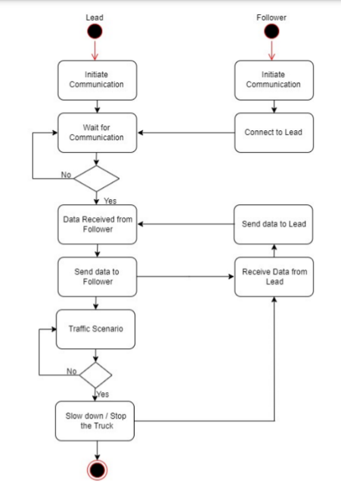

Figure 1: Activity Diagram of Truck Platooning

## Block Definition Diagram[Author: VigneshArumugam]

The whole system has been analyzed and the components of the systems has been created as the block and the relationship between the blocks has been done with association connectors. Each individual block has been added with its corresponding attributes and operations.

## Sequence Diagram[Author: Nijat Dashdamirov]

Sequence diagram is used to describe types and orders of the interactions between objects. In our case we have 4 main objects: “Platoon Central Unit”, “GPS”, “Camera” and “Wi-Fi”. “Process Central Unit” is used to control all the system and it is main object in the diagram. Firstly, PCU send UpdataTXFrame() message to update data in the Wi-Fi object. Then UpdateRxFrame() is send from Wi-Fi object to the PCU to update the Wi-Fi credentials. Once this is done PCU is getting and updating the coordinates of the leading truck via UpdateCoordinates() message. Lidar object is getting the distance between the trucks and sends the data to PCU using UpdateGap(). To check the platooning is working flawless and there is no un-platooned truck in the system, every time we are getting information from the camera. Once camera senses that there is an intruder in the system, it sends message UpdateIntruder() to the main block to inform controller.

## Parameteric Contraint Diagram[Author: VigneshArumugam]

Parametric constraint diagram has been added along with the block diagram. The constraints of the block are mentioned in the natural language.

## Allocation Diagram[Author: Namık Mert Tunçbilek]

Allocation diagrams are used to define relationship of various parts of the model. In our case, the relationship of four different blocks of platoon is shown.

## Internal Block Diagram[Author: Namık Mert Tunçbilek]

## State Machine Diagram[Author: Veli Ates]

## State machine diagrams are typically are used to describe state-dependent behavior for an object. An object responds differently to the same event depending on what state it is in. State machine diagrams can be shown uniquely depending on the system and components that are going to be chosen based on requirements. In this case, 3 different components(Vehicle, Sensor and Platoon) are chosen to show their behaviors in spesific circumstances.

## Vehicle Component: The vehicles in the platoon may vary according to the user's requirements. But every vehicle must have some states in the platoon. In our case, “vehicle component” has 9 states.

*Each state represents the current position of the component. The main purpose of the whole tasks is to make sure if the component works properly.*

## 

* Sensor Component: The sensor component is used to ensure if the distance between the vehicles is equal to the safe distance. In order to do that, sensor has to receive signals from leader vehicle to calculate the distance.

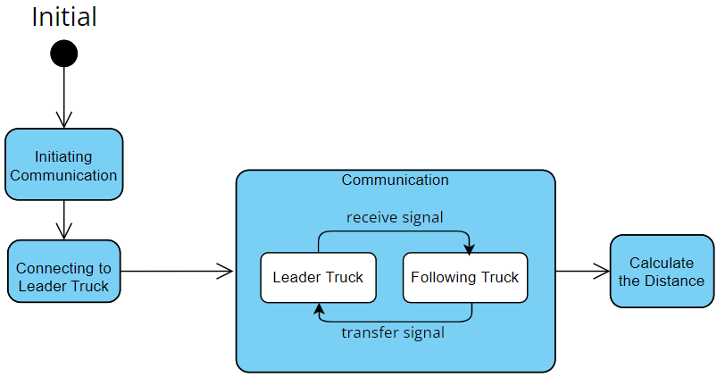

* Platoon Component: Platoon is a component represents of the whole system. This component has 7 states in which all the tasks should be done properly.

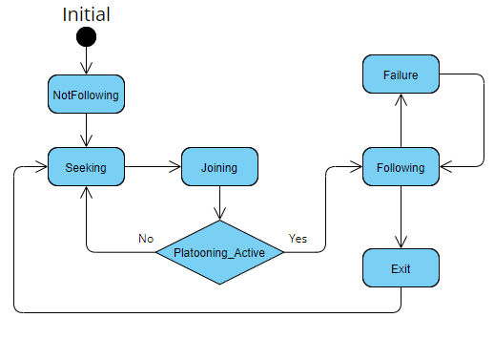

# Implementation Section

After the analysis and design part, the realization has started with implementation section in the following order.

## Code Implementation[Author: VigneshArumugam]

The code implementation is handled in CPP language and the Arduino ESP32 has been chosen as the hardware and the part implementation of platooning control unit component is done.

## Scheduling[Author: VigneshArumugam]

The simso software has been used to show the schedulable of the tasks in both EDF and RMS methods.

# Review and Testing

## Inspection[Authors: All team members]

The review has been done for all the models and mentioned in the google review sheets.

## Unit testing[Author: Namık Mert Tunçbilek]

## Component testing

## Basically, component testing is to test the all the object that is communicating with PCU. Firstly, I test the Wi-Fi management. In this case I uploaded the Rx frame of the Wi-Fi and check that if it is updated correctly. As coordinates of the leading truck is important in our case, to check weather if it is working or not, I give random value to longitude and latitude and compared the new value with previous one. To check intruder in the system, I update the intruder value as true and overall system decreased the speed in order to prevent collision to happen. Because it is important to keep the distance as predefined, I increased the distance between the two adjacent truck and system decreased the speed to have normal distance between the trucks.

# Conclusion

The whole project has been analysed, implemented and tested in the

##### Acknowledgment

##### We sincerely thank all the members who supported us throughout the journey of this paper and for all the contributions they have made on this paper. We appreciate for their continuous guidance and cooperation.

##### References

1. Ellwanger S, Wohlfarth E. Truck platooning application. In2017 IEEE Intelligent Vehicles Symposium (IV) 2017 Jun 11 (pp. 966-971). IEEE.J. Clerk Maxwell, A Treatise on Electricity and Magnetism, 3rd ed., vol. 2. Oxford: Clarendon, 1892, pp.68–73.
2. Calvert SC, Schakel WJ, van Arem B. Evaluation and modelling of the traffic flow effects of truck platooning. Transportation research part C: emerging technologies. 2019 Aug 1;105:1-22.K. Elissa, “Title of paper if known,” unpublished.
3. Saeednia M, Menendez M. Analysis of strategies for truck platooning: Hybrid strategy. Transportation Research Record. 2016;2547(1):41-8.
4. Janssen GR, Zwijnenberg J, Blankers IJ, de Kruijff JS. Truck platooning: Driving the future of transportation.
5. Zhang L, Chen F, Ma X, Pan X. Fuel economy in truck platooning: a literature overview and directions for future research. Journal of Advanced Transportation. 2020 Jan 3;2020.